Project Design Phase
Problem – Solution Fit Template

Date | 26 September 2026
Team ID | SWTID-2026-9430
Project Name | AI BlogNest API
Maximum Marks | 2 Marks

Problem – Solution Fit – AI BlogNest
The Problem-Solution Fit for AI BlogNest focuses on identifying the challenges users face while creating, organizing, and managing blog content. The solution provides AI-powered assistance to simplify content creation, improve writing quality, and save time. It helps entrepreneurs, marketers, students, and content creators understand user needs, identify common behavioral patterns, and provide an effective solution that addresses their blogging requirements.

Purpose – AI BlogNest
❑ Identify and solve common blogging and content creation challenges based on the actual needs of users.
❑ Improve user adoption and achieve faster results by using familiar digital platforms and content-sharing channels.
❑ Strengthen communication and marketing strategies through relevant messages, user needs, and effective engagement methods.
❑ Increase user interaction with AI BlogNest by addressing frequent content creation difficulties and providing quick, useful solutions.
❑ Understand the current blogging experience of the target users and use those insights to improve their overall content creation process.

Template:

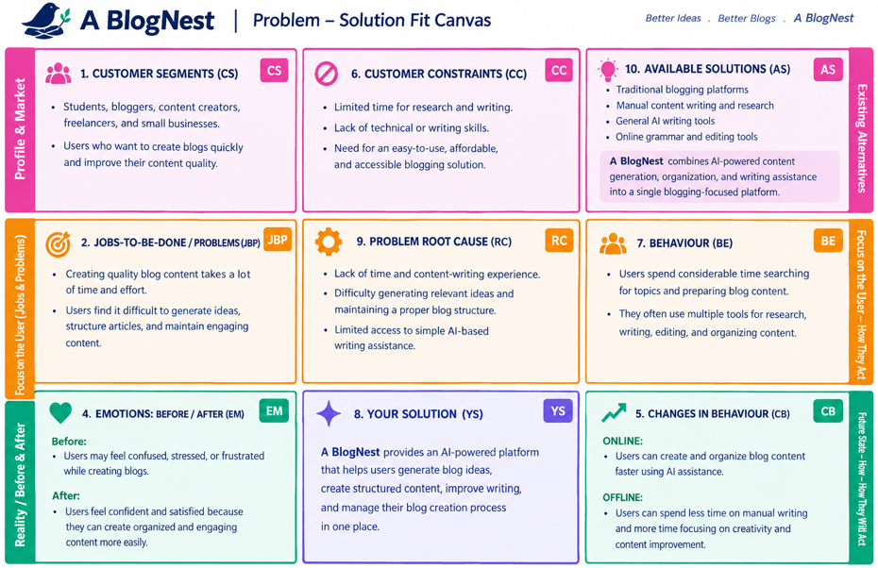

References:
- https://www.ideahackers.network/problem-solution-fit-canvas/

- https://medium.com/@epicantus/problem-solution-fit-canvas-aa3dd59cb4fe

